3.1 I can assess the effectiveness of different project management techniques

Doing this project for 2.1 to 2.5’s work, creating web pages and CSS to create a working website has taught me several things:

One of the main things is that I didn’t do enough research on how Trello and Agile methods work and how to organise them and how to keep them up to date. Although I did try my best.

<https://trello.com/b/EyZmURbi/project>

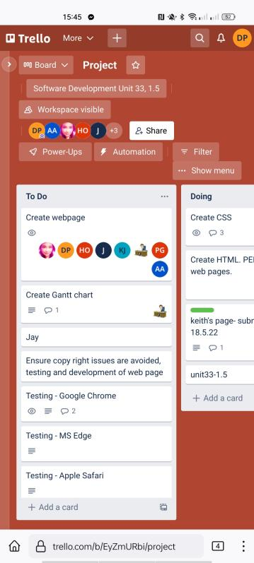

[Above is an image showing our Trello.com website with the progress section full]

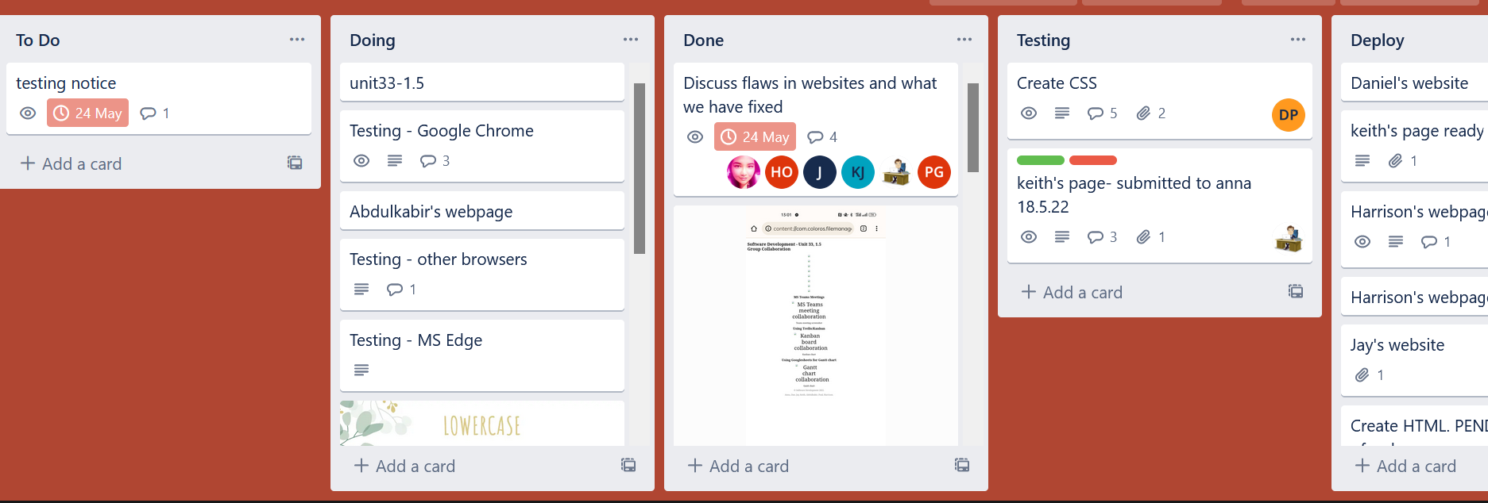

[Above is an image showing our Trello.com website as the progress section is nearly empty and the rest has been spread across over sections]

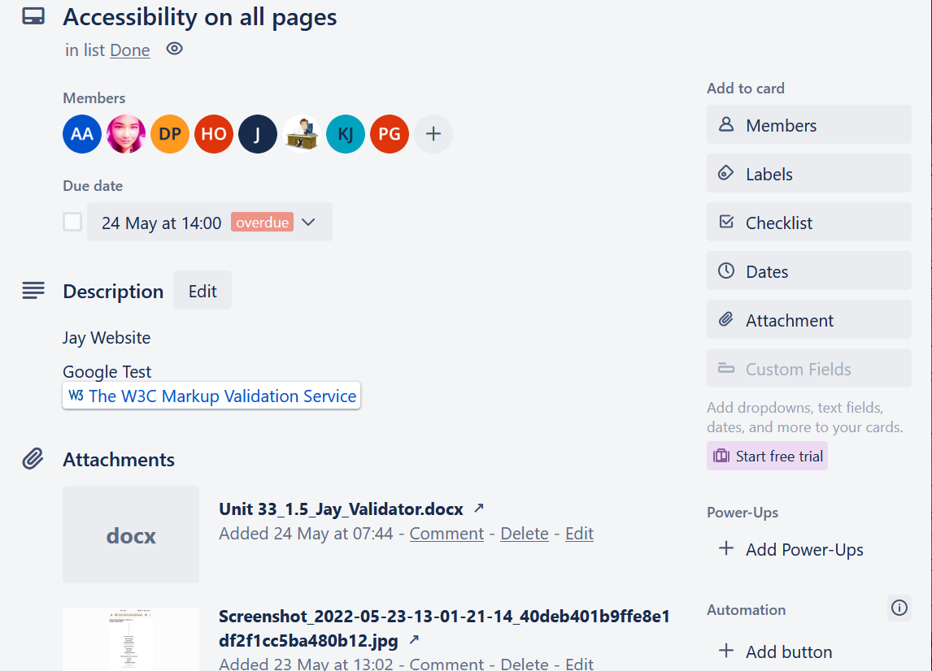

[Above shows an image of a card opened on our Trello.com website]

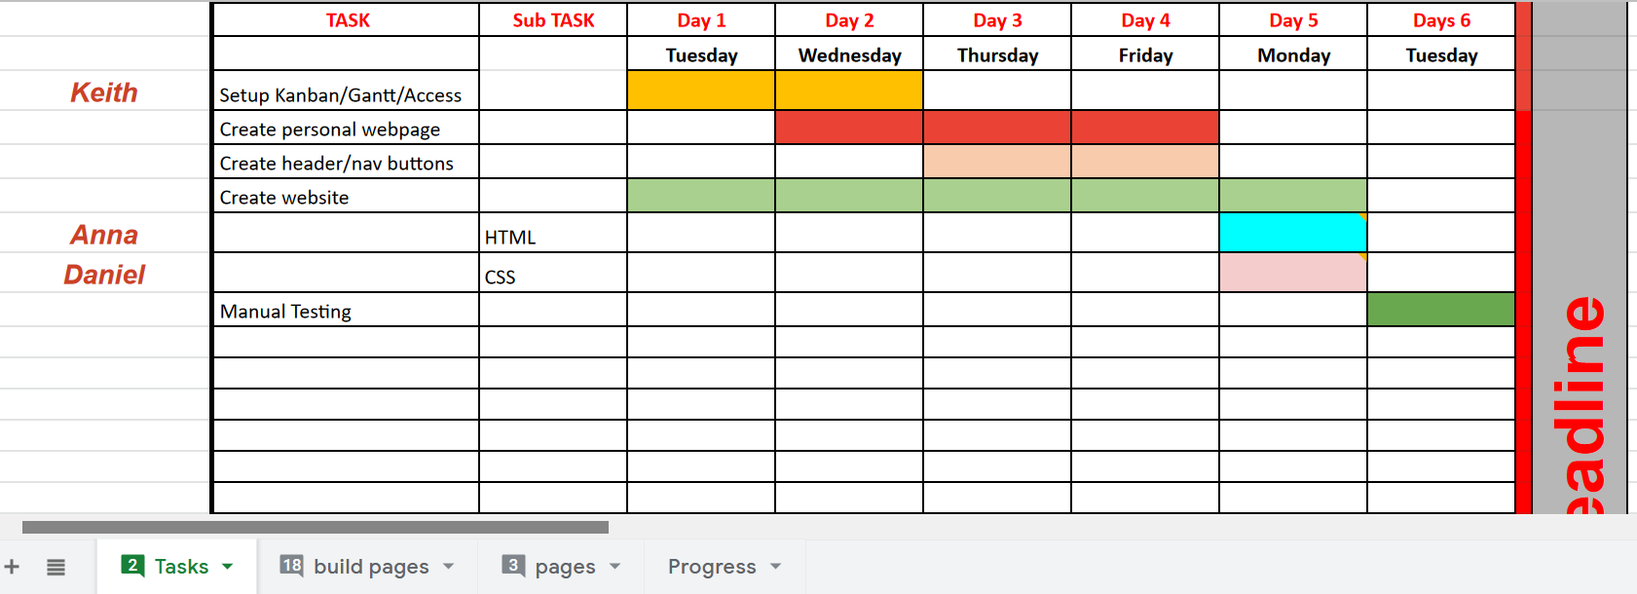

[Above shows the Gantt chart that we used, it shows the progress that we should make throughout the week]

**Comparison**

The Waterfall method would have meant that we could only create the web pages one by one and test one by one before showing each other the end product but with Agile we could create multiple web pages and share each one on the <https://trello.com/b/EyZmURbi/project> website to keep everyone involved and they could share their ideas and help if ever one person got stuck.

Along with the Gantt chart and Trello.com in full swing, it helped us know our progress, compared to if we just had our own time-lines and only communicated once about what we needed to do and had no external communication.

Waterfall method also would mean that we couldn’t finish all the websites on time because we would have to discuss each one before we moved onto the next. Agile method meant that we discussed what we wanted with each web page and discussed what we expected from the outcome.

**Conclusion**

In our project we used Agile methoding, it was sort of confusing at times and some people didn’t know how to keep most of it updated or to keep checking it but I tried my best to keep everyone focussed on the tasks that needed doing the most by organising the Trello board. I think if we just used emails or another form of methods to communicate like Microsoft teams or Adobe Connect then the project wouldn’t have been finished in the time-frame we had, even with our short extension.